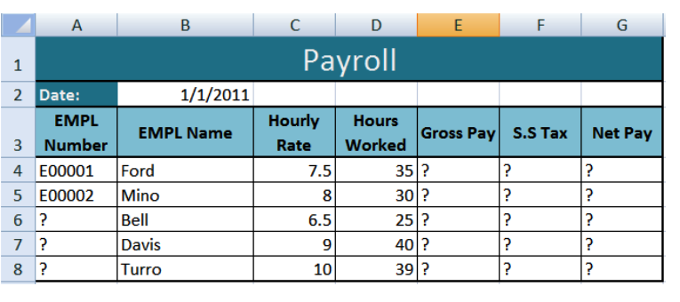

**Ques. – 1**

1. **Open a new workbook and save the file with the name “Payroll”.**
2. **Enter the labels and values in the exact cells locations as desired.**
3. **Use AutoFill to put the Employee Numbers into cells A6:A8.**
4. **Set the columns width and rows height appropriately.**
5. **Set labels alignment appropriately.**
6. **Use warp text and merge cells as desired.**
7. **Apply borders, gridlines and shading to the table as desired.**
8. **Format cell B2 to Short Date format.**
9. **Format cells E4:G8 to include dollar sign with two decimal places.**
10. **Calculate the Gross Pay for employee; enter a formula in cell E4 to multiply Hourly Rate by Hours Worked.**
11. **Calculate the Social Security Tax (S.S Tax), which is 6% of the Gross Pay; enter a formula in cell F4 to multiply Gross Pay by 6%.**
12. **Calculate the Net Pay; enter a formula in cell G4 to subtract Social Security Tax from Gross Pay.**
13. **Set the work sheet vertically and horizontally on the page.**
14. **Save your work.**